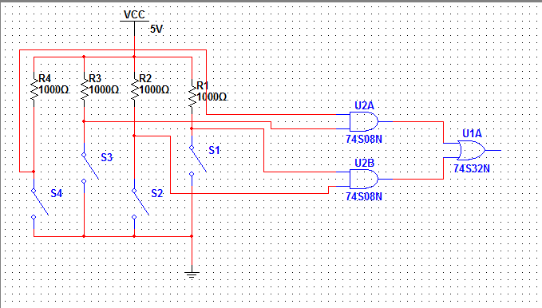

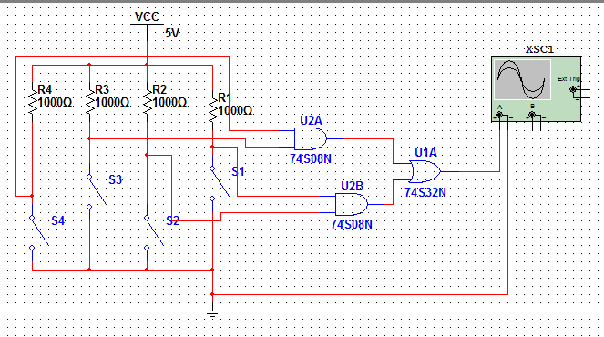Lab 3

# Purpose

The purpose of this lab is to begin investigating combinatorial circuits.

# Objective

This lab provides the student with the following:

* Practice using Multisim
* An introduction to the oscilloscope
* Boolean Expressions
* More Experience in Circuit Testing and Verification
* Familiarization with combinatorial circuits.

# Procedure

## Part A – Using the Oscilloscope with a Combinatorial Circuit

1. Implement the AND-OR logic circuit in Multisim (figure )
2. Then, take your circuit and attach the oscilloscope to its output (The oscilloscope is found in the tools gallery)

|  |  |  |  |  |
| --- | --- | --- | --- | --- |
| **TRUTH TABLE** | | | | |
| **S4** | **S3** | **S2** | **S1** | **S. Out** |
| 0 | 0 | 0 | 0 | 0 |
| 0 | 0 | 0 | 1 | 0 |
| 0 | 0 | 1 | 0 | 0 |
| 0 | 0 | 1 | 1 | 1 |
| 0 | 1 | 0 | 0 | 0 |
| 0 | 1 | 0 | 1 | 0 |
| 0 | 1 | 1 | 0 | 0 |
| 0 | 1 | 1 | 1 | 1 |
| 1 | 0 | 0 | 0 | 0 |
| 1 | 0 | 0 | 1 | 0 |
| 1 | 0 | 1 | 0 | 0 |
| 1 | 0 | 1 | 1 | 1 |
| 1 | 1 | 0 | 0 | 1 |
| 1 | 1 | 0 | 1 | 1 |
| 1 | 1 | 1 | 0 | 1 |
| 1 | 1 | 1 | 1 | 1 |

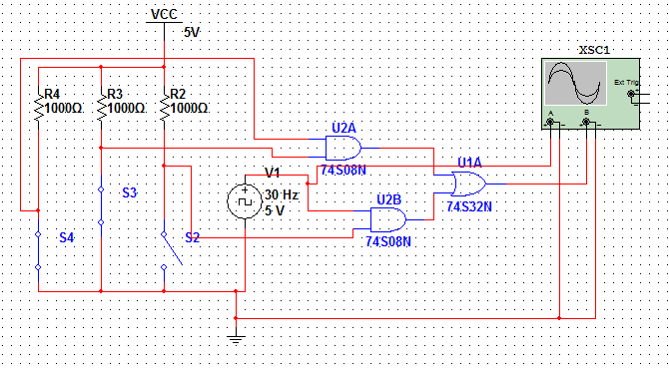

1. Turn on the circuit and double click on the oscilloscope in your circuit. This will bring up a new window with a large graph and some options below
2. Turn on your circuit and collect your results. Result:
3. Replace S1 with a clock voltage source set for 30 Hz. Connect the oscilloscope as seen in figure
4. Quickly open the oscilloscope window again and change channel A to be 1 division above center and channel B to be 2 divisions below center.
5. Turn on your circuit and comment in your lab book what you see when S2 is open and both S3 and S4 are closed.

Result:

## Part B – Circuits from Boolean Expressions

1. Implement a circuit in Multisim which 0

**A * 1 = A**

1. Add an oscilloscope to the circuit such that the 25 Hz signal at the input of U1A is connected to Channel A of the oscilloscope and is displayed on the upper portion of the screen. The output from UA1 is connected to Channel B and is displayed on the lower portion of the screen.

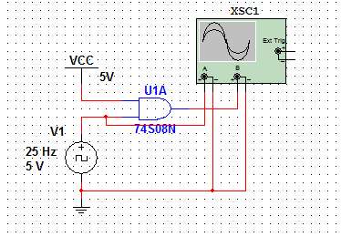

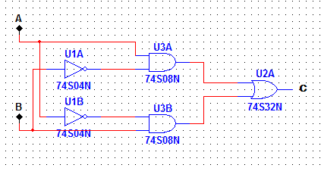

|  |  |  |
| --- | --- | --- |
| **TRUTH TABLE** | | |
| **S4** | **S3** | **S. Out** |
| 0 | 0 | 0 |
| 0 | 1 | 1 |
| 1 | 0 | 1 |
| 1 | 1 | 0 |

1. Implement the solution above and demonstrate it to your instructor
2. In your lab book, show the Boolean expression, it’s logical circuit cousin, and sketch the circuits’ output

## Part C - Boolean Expressions from Circuits

1. Given the circuit found in figure. , derive the Boolean expression (the sum of the product) and write it in your lab book.
2. Implement the circuit in Multisim using switches for inputs: A and B, and a logic probe for the output: C.
3. Create a truth table and record the output that corresponds to each of the input combinations. Do the results confirm your Boolean expression as being correct? What can you say about the behavioural characteristics of this circuit?

## Part D – A Combinatorial Circuit

1. Draw the circuit that is described by the expression: A!BC + !AB!C + ABC in your lab book.
2. Implement the circuit in Multisim using switches for the inputs and verify your truth table
3. Demonstrate the circuit to your instructor. Be sure that your circuit is correct before proceeding.

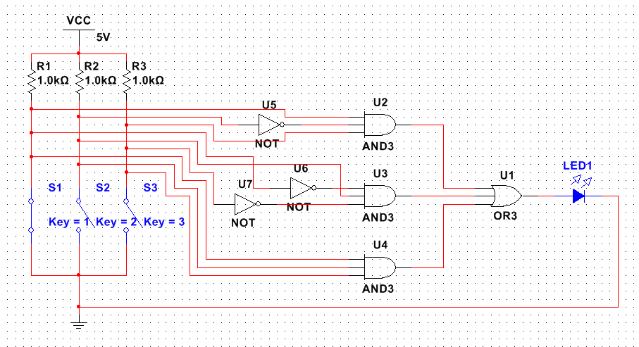

|  |  |  |  |  |
| --- | --- | --- | --- | --- |
| **TRUTH TABLE** | | | | |
| **A** | **B** | **C** | **Out** | **Verify** |
| 0 | 0 | 0 | 0 |  |
| 0 | 0 | 1 | 0 |  |
| 0 | 1 | 0 | 1 |  |
| 0 | 1 | 1 | 0 |  |
| 1 | 0 | 0 | 0 |  |
| 1 | 0 | 1 | 1 |  |
| 1 | 1 | 0 | 0 |  |
| 1 | 1 | 1 | 1 |  |

## Part E – Solving a problem with a Combinatorial Circuit

The Problem:

“You are asked to design an elevator control system for hotel that has four elevators. Three of the elevators are turned on all of the time, ready to be used. The fourth elevator is off and is activated only when all of the other three are in use.

The control system you are to build is to have as inputs, an output from each of the three motor control boards – one board for each of the three elevators (which are always on and ready for use). If the input has a logic “1” that indicates that the elevator is in use while a logic “0” indicates the elevator, though on, is not in use.

The output of your design is to activate (i.e. turn on) the relay controlling the fourth elevator with a logic “1” to turn on the fourth elevator when all of the other elevators are in use.

Your recorded work in the lab book should show all steps you took to design your circuit and must show that verified your design. Feel free to make sketches. You must show your lab book entries and perform a demonstration for your instructor.”

1. Collect your circuit requirements in a truth table
2. Analyse your truth tables and use your previous experience to determine which discrete gates will generate those results
3. Build your circuit in multisim using the gates you picked in the previous step and check if it works.

Result: